Links to Sprint 5 Tableau Project, Pen & Paper Mock-Ups & Screen Recording Presentation

[Ramon Rivera- Sprint 5 Superstore Returns Project | Tableau Public](https://public.tableau.com/app/profile/ramon.rivera4922/viz/RamonRivera-Sprint5SuperstoreReturnsProject/ReturnRatesSalesVSSub-Category?publish=yes)

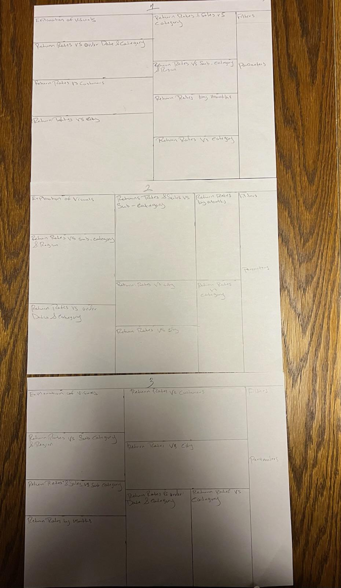

[Tableau Public - Ramon Rivera- Sprint 5 Superstore Returns Project 2 2025-08-18 17-28-13.mp4](https://drive.google.com/file/d/1fa4Plr2REYV3Ru96A1W2WkiuIvTwoTnh/view?usp=sharing)